Arik Segal
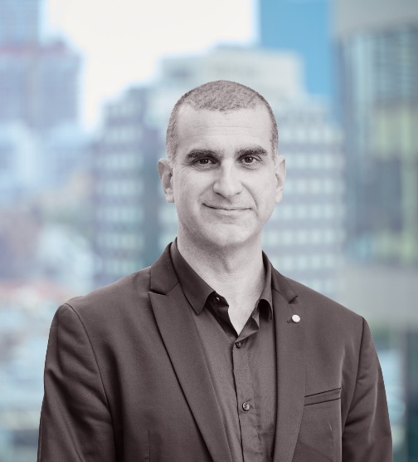
Arik Segal is a mediator and an educator who specializes in conflict resolution and digital influence. He works as an independent consultant through his company “Conntix” .
He holds an HBA in International Relations from the University of Toronto and a Master’s degree from Tel Aviv University in Diplomacy Studies, as well as a Mediator's certificate from Gevim Group.
Arik works in cooperation with international organizations, governments and think tanks [such as: US Embassy in Jerusalem, The Israeli Ministry of Foreign Affairs, The Israeli Internet Union and others]
He leads digital campaign influence projects and facilities cross-cultural dialogue projects. He regularly publishes op-eds on various media platforms and speaks at academic and professional international conferences.
Arik is an award-winning lecturer at Reichman and Bar-Ilan Universities, where he teaches courses about negotiation, crisis management and digital political campaigns. He also teaches at the IDF’s College for Tactical Command about information warfare, Based on his extensive experience on the topic.
Arik is a US State Dept. international exchange alumni and a graduate of the international academy for leadership in Gummersbach, Germany. He established the "Israeli IR Pros" group.

